Contact: Anna Sacca | asacca@fsbassociates.com | 760.585.2252

“This is an introspective work . . . a fascinating examination of how daughters make peace with their moms.” ―Kirkus Reviews

Dear Editor:

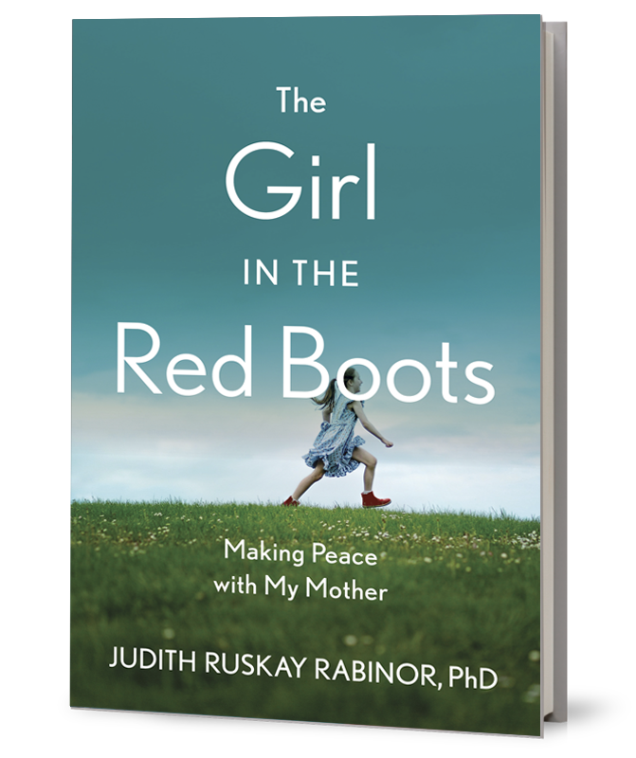
I’m pleased to share The Girl in the Red Boots: Making Peace with My Mother (She Writes Press; May 4, 2021; $16.95, paperback, 978-1647420406; 288 pages) by Judith Ruskay Rabinor, PhD.

While Dr Judy Rabinor, an eating disorder expert, is leading a seminar, she is blindsided by a memory of a childhood trauma that has resonated throughout her life.

The Girl in the Red Boots weaves together tales from her life and her psychotherapy practice, helping readers appreciate how painful childhood experiences can linger and leave emotional scars. In the process, Rabinor traces her own journey becoming a wounded healer and ultimately makes peace with her mother— and herself. The Girl in the Red Boots is a soulful exploration of the mother-daughter bond.

Rabinor is available for interviews and virtual events. I look forward to discussing coverage opportunities.

Thank you,
Anna Sacca

ABOUT THE AUTHOR: Judith Ruskay Rabinor, PhD, is a clinician, author, writing coach, speaker, and workshop leader. In addition to her New York City private psychotherapy practice, she offers remote consultations for writers, clinicians and families. She has published dozens of articles for both the public and professionals and has authored three books, The Girl in the Red Boots: Making Peace with My Mother (She Writes Press, 2021), A Starving Madness: Tales of Hunger, Hope and Healing in Psychotherapy (Gurze Books, 2002) and Befriending Your Ex After Divorce: Making Life Better for You, Your Kids and Yes, Your Ex (New Harbinger Publications, 2012). A sought-after speaker and workshop leader, Judy speaks at national and international mental health conferences and runs workshops at spas, colleges and universities and retreat centers. Please visit: https://judithruskayrabinorphd.com

ADVANCE PRAISE:

“In this engaging book, Rabinor reflects on the most complex, intense and important of all relationships, the one between mothers and daughters. She shares the story of her journey from pain and anger to acceptance and gratitude and explores the journeys of other mothers and daughters too. Rabinor’s professional work with eating disorders has given her a unique vantage point on these most timeless of stories. Her book is candid, fresh and inspiring.” ―Mary Pipher, author of Women Rowing North and Reviving Ophelia

“The complex relationship between mothers and daughters is brought vividly to life as Rabinor, a psychologist who specializes in mother-daughter relationships, weaves together stories from her office and her life. As she helps others, she sorts out a lifetime of her own unresolved feelings. A riveting read that reminds us that parenting is fragile, love is always flawed and it’s never too late to understand ourselves and our mothers.” ―Jane Goldberg, author of The Dark Side of Love

“Mother loss comes in many different forms, as Judy Rabinor explores in this affecting story of the fractured, flawed mother-daughter relationship that entangled her for decades. As a long-time psychotherapist, Rabinor is an expert on grief and healing. As a daughter, she longed for a deeper connection with a mother whose imperfect love, ultimately, left her with valuable gifts and insights to share. Both of those threads make The Girl in the Red Boots a unique and valuable contribution in the bereavement field.” ―Hope Edelman, New York Times best-selling author of Motherless Daughters, Motherless Mothers, and The Aftergrief

“Dr. Judy Rabinor is not only a master clinician and teacher but also an extraordinarily gifted weaver of a tapestry of healing. The Girl in the Red Boots beautifully illustrates how our own wounds and vulnerabilities can truly inform and inspire our work with our clients. And it also reveals all the ways our clients’ journeys can inform and inspire our own healing and recovery. But this book is not simply for psychotherapists and their clients. It’s a book for all mothers and daughters everywhere. Actually, speaking as a son and a father, it’s a book for all of us. Read it. It will open your heart.” ―David Treadway, PhD, author of Treating Couples Well: A Collaborative Guide to Collaborative Family Therapy

“A compelling read. The Girl in the Red Boots delves into things often not spoken of by therapists. Judy works, thinks and shares perspectives outside the box. Readers are left with a beautiful reminder that giving respect and compassion. To others’ pain makes just a bit easier to give it to your loved ones and yourself.”
— Carolyn Costin, founder of The Carolyn Costin Institute and author of 8 Keys to Recovery from an Eating Disorder

